ABSTRACT

ABSTRACT
This project is aimed at developing a software useful for collage administration.
SIS is a VB.Net application that can be accessed throughout the staffs at the administration work. This software is useful to input information quickly about student details like personal information and official like certificates. The software is mainly developed for make work computerized usage and developed in a manner that is easily manageable, time saving and relieving one from manual works. Nowadays many of the institutions done this kind of works in manually. So I have to change it and encourage the admins.

Here we have only four Modules in the software,
- Login
- Student information entry
- Student information viewer
- Students certificate viewer

Front end: VB.Net.
Back end: MS Access.

INTRODUCTION

1. INTRODUCTION
1.1 OVERVIEW OF THE PROJECT
The project entitled “Student Information System” Creation for required to keeping the management. Discount and stock notification is the main part of this project. In the present system student information are maintaining manually. The records are collected manually. It will take lot of time to collect the data. The person once again checks the records and then the data are collected. The certificates of the student will be recorded in one ledger and to maintain that ledger for later purpose. For the student detail report, enter details of student issued by the organization and maintain the notebook ledger. For that the student id wise stocks of the entire student records are also maintained.
Separate ledgers were used for preparing the department wise information, academic year wise information. This type of above work is very difficult one and also it need more man power and unnecessarily maintaining the ledgers. So to analyze this type of work, this project has developed software that gives a ‘Maintenance System’ of all the records in general in the organization.
This Project reduces manual time consumption. The required data can be accessed immediately. Saving and Retrieval of data is day-to-day transactions. There is no chance of missing records or keeping in loose leaf. The records can be maintained in table formats. Here we are creating separate forms for all the processing like entry, viewer, etc.

1.2 ORGANIZATION PROFILE
Parvathy’s Arts and Science College is one of the many folded contributions of K.K.R. Natarajan, N.Parvathy Ammal Educational Trust. It is founded by an eminent business family in Dindigul with the noble vision of imparting quality higher education and employment for all.
Sprawling over 60 acres of land the college campus, “Wisdom City” is ideally set on the Dindigul – Madurai (NH-7) Road, hardly 3 Kms from Dindigul town, easily accessible and well connected to even interior rural areas with town buses. The college is a co-educational self-financing Institution affiliated to Madurai Kamaraj University and is approved by the Government of Tamil Nadu. It admits students as per the norms specified by the state government and by the Madurai Kamaraj University.
An array of high-class infrastructural facilities is made available to enable the students to excel themselves in their branches of study. We intend to offer a truly international class learning experience with renowned teachers and to promote the college as a reputed center for Higher Education in the southern part of Tamil Nadu.
Comprehending the fact that ‘Class-room Study’ alone will not help the students to earn a lively-hood, to come up in life, to serve the society and to become a responsible and loyal citizen of our country the college with the invaluable guidance of the management offer many extension activities like soft skill Training, Industrial Exposure and Job oriented Training Programs. It is the youngest institution to get 159 University Ranks in a short time. This Institution has committed fully for the cause of the students and academicians with fall faith in the motto of “Wisdom Leads”.

ABOUT THE SOFTWARE
VB.NET
VB.Net has revolutionized windows programming windows programming and with an object based, event driven approach to software designs. Visual basic.Net applications act as a front end to the database. Visual basic.Net application provides the interface between the user and the database. Sophisticated features that make the language truly object oriented and interfaces it with the latest in the database technology.
.NET provides a new, object-oriented API as a set of classes that will be accessible from any programming language. This book describes this framework of classes and provides a reference to what is available and how you can use this framework to write Windows applications in the brave new world of .NET.
Microsoft .NET Framework is a computing platform for developing distributed applications for the Internet. Following are the design goals of Microsoft .NET Framework:
- To provide a very high degree of language interoperability
- To provide a runtime environment that completely manages code execution
- To provide a very simple software deployment and versioning model
- To provide high-level code security through code access security and strong type checking
- To provide a consistent object-oriented programming model
- To facilitate application communication by using industry standards such as SOAP and XML.
- To simplify Web application development
Visual basic.net lets the user to add menus, text boxes, command buttons, option buttons, check boxes, list boxes, scroll bars, and file directory boxes to blank windows. Visual basic.net has many different tools.

The Common Language Runtime
The CLR is the mechanism through which .NET code is executed. It is built upon a single, common language—IL—into which source languages are compiled and includes mechanisms for executing the compiled code. This includes code verification and just-in-time (JIT) compilation, garbage collection and enforcement of security policies, and the provision of profiling and debugging services.
The CLR provides a lot of added value to the programs it supports. Because it controls how a .NET program executes and sits between the program and the operating system, it can implement security, versioning support, automatic memory management through garbage collection, and provide transparent access to system services.
The user interface is the part of the program that responds to the key press and mouse clicks. The action is referred to as events of the form and controls in the form. The form is a visual object where a set of object controls is placed to communicate with backend databases and validation checks. VB.NET provides a vast properties and methods for each control, which helps to utilize all those, functions for record manipulations.
IMPORTANT FEATURES
- The application is a graphical user interface.
- Client-Server architecture benefits picture and image box can be easily handled using bit mapped files and icons.
- Bit mapped files and icons are used as simple debugging tools.
- With the advent of .NET, Microsoft has introduced many new technologies that make writing component-based distributed systems easier, more flexible, and more powerful than ever before.
- It is now easier than it has ever been to write components in any programming language that can interoperate with components on other machines, which may not be Windows-based at all.

MS ACCESS
The purpose of this document is to help you migrate your applications when you are migrating the underlying database from Microsoft Access to Some other Database. Most of the issues encountered when migrating applications to use an MS Access Database are related to database incompatibility. This paper presents these incompatibilities and provides solutions for many issues. It familiarizes yourself with this document prior to migrating your databases. The choices made about how to migrate your application affect how you migrate the underlying database from Microsoft Access to some other Database.
If the application uses the Microsoft OLE DB Provider for MS Access or a third-party OLE DB Provider to connect the Microsoft Access database, use the Microsoft.ACE.OLEDB.12.0 Provider for OLE DB (Microsoft.ACE.OLEDB.12.0) to connect to the migrated Database.
There are quite a few reasons, the first being that MS Access is a feature rich program that can handle any database related task you have. You can create places to store your data build tools that make it easy to read and modify your database contents, and ask questions of your data. MS Access is a relational database, a database that stores information about related objects. In MS Access that database means a collection of tables that hold data. It collectively stores all the other related objects such as queries, forms and reports that are used to implement function effectively.

SYSTEM ANALYSIS

2. SYSTEM ANALYSIS
2.1 EXISTING SYSTEM
The existing system is manual one .The major activities are related to organization or admins are usually carried out in a hectic way. The number of students arrival is on alarming rate on the manual data collections and the work of the ledgers always contain in a errors which are great loss to the admin. And of lately this package which was proposed that they have thought of implementing a change so the existing system has been manual one and it has been burden on various activities where all needed to carry out the existing system. At last we lots of notebook ledgers for particular student details on the order of department and academic year wise.
    - DRAWBACKS OF EXISTING SYSTEM
- Erroneous data entry due to human errors.
- Searching and verifying of exact data are more time consuming.
- Reports are not in a presentable form.
- Loss of past records due to mishandling and improper storage facilities.
- Slow processing.
- Consume lot of man power on the process.

2.2 PROPOSED SYSTEM
The proposed system is been developed to maintain systemized the record entry, record viewer, certificate viewer, etc. The drawbacks, which are faced in the existing system, can be overcome by using the proposed system. The system, which is proposed, now computerizes all the details that are maintained manually. Moreover here one platform that contain all type of records like department wise and academic year wise.
2.2.1 ADVANTAGES OF PROPOSED SYSTEM
- It is very accurate
- Records are very securely maintained.
- Very good at certificates collection.
- All the process has done at high speed.
- It does the work very efficiently.
- It is cost effective.
- Reduced paper work.
- No more lots of ledgers.
- A very big advantage on the process.

SYSTEM SPECIFICATION

3. SYSTEM SPECIFICATION
3.1 HARDWARE SPECIFICATION
System : Aspire E1 - 431
Processor : Intel Pentium CPU B950
RAM : 2 GB
Hard disk : 300 GB
Mouse : Track Pad
Keyboard : Standard PS/2 Keyboard
3.2 SOFTWARE SPECIFICATION
Operating System : Windows 8
Front End : VB.NET
Back End : MS Access 2013
Software : Microsoft Visual Studio 2010

SYSTEM DESIGN

4. SYSTEM DESIGN
INPUT DESIGN
Input design is the process of converting the user-oriented. Input to a computer based format. The goal of the input design is to make the data entry easier, logical and free error. Errors in the input data are controlled by the input design. The quality of the input determines the quality of the system output.
The entire data entry screen is interactive in nature, so that the user can directly enter into data according to the prompted messages. The user are also can directly enter into data according to the prompted messages. The users are also provided with option of selecting an appropriate input from a list of values. This will reduce the number of error, which are otherwise likely to arise if they were to be entered by the user itself.
OUTPUT DESIGN
Output design is very important concept in the computerized system, without reliable output the user may feel the entire system is unnecessary and avoids using it. The proper output design is important in any system and facilitates effective decision-making. The output design of this system includes various reports. Computer output is the most important and direct source of information the user. Efficient, intelligible output design should improve the system’s relationships with the user and help in decision making.
DATABASE DESIGN
A database should provide integration, Integrity and a data independence table in a database contains information pertaining to a specific entity. To maintain the tables in an effective way, it should be normalized to ensure that the number of tables does no exceed the optimum level unless it is mandatory. To prevent unauthorized access, security measures have been provided. This may prevent unauthorized persons using data that is private. The normalization techniques have been used to design the table such that the use of all the tables is made easy. The various relations between different tables, the number of fields in each table and the type, width of each field were analyses. The names of the fields and tables where so chosen that the users would not face any problem in identifying the table structure.

4.1 DATA FLOW DIAGRAM
Level: 0
Student Information System
Admin
Admin

Level 1
student
Login
Entry form
Admin

Filtering details

Proofs details

Info

Admin

4.2 SYSTEM FLOW DIAGRAM
Login

Admin

Manage
Storage

Entry Form

Info

Proofs viewer

Student details
Viewer

Student database

Report

4.3 TABLE DESIGN
Table Name: Student
Field Name | Data type | Description
sid | Number | Student ID
sname | Short text | Student name
fname | Short text | Father’s name
gender | Short text | Gender of the student
dob | Date/Time | Date of birth
religion | Short text | Religion of the student
community | Short text | Community of the student
address | Long text | Address of the student
phone | Long text | Phone number
email | Long text | E-mail
Department | Short text | Department of the student
ayfrom | Date/Time | Academic year from
ayto | Date/Time | Academic year to
jd | Date/Time | Join date
rollnum | Short text | Roll number of the student
regnum | Short text | Register number of the student
10mp | Long text | 10th marksheet
12mp | Long text | 12th marksheet
12tc | Long text | 12th Transfer Certificate
aadharp | Long text | Aadhar card image
passbookp | Long text | Pass book image
communityp | Long text | Community Certificate image

TESTING

5. TESTING
5.1 TESTING METHODOLOGIES
Software testing is a critical element of software quality assurance and represents the ultimate reviews of specification, design and coding. Testing presents an interesting anomaly of the software. During earlier definition and development phases, it was attempted to build software from abstract concept to a tangible implementation.
The testing phase involves the testing of the developed system using various set data. Presentation of test data plays a vital role in system testing. After preparing the test data the system under study was tested using test data. The various types of testing done on the system are: Testing methodology
- Unit Testing
- Integration Testing
- Validation Testing
- White box testing
- Black box testing
5.1.1 UNIT TESTING
Unit testing focuses verification effort on the smallest unit of software design, the module. It comprises the set of test performed by the programmer prior to integration of the unit into larger system. The testing was carried out during the coding stage itself. In this step each module is found to be working satisfactorily as regards to the expected output from the module.
5.1.2 INTEGRATION TESTING
Integration testing is a systematic technique for constructing the program structure while at the same time conducting tests to uncover error associated within the interface. The objective is to take unit tested modules and build a program structure that has been dictated by design. All modules are combined in this step. The entire program is tested as whole. And chaos in interfaces may usually result. A set of errors is encountered in such a case.
5.1.3 VALIDATION TESTING
Here in the validation testing we want to check whether the given conditions to the text box are working correctly. Because in the name place we want to enter the characters and the special symbols only we should not enter the numbers in the name field. Here while on runtime we entered numeric values in the string specified columns of product inwards. It raises error. In this phase each module has been tested by wrong inputs, for example Employee Name should be a character as well as their age should be in numbers.
5.1.4 WHITEBOX TESTING
White box testing, sometimes called glass-box testing is a test case design method that uses the control structure of the procedural design to derive test cases. Using white box testing methods, the software engineer can derive test cases.
- Guarantee that all independent paths within a module have exercised at least once.
- Exercise all logical decisions on their true and false sides.
- Execute all loops at their boundaries and within their operational bounds.
- Exercise internal data structures to ensure their validity.
5.1.5 BLACK BOX TESTING
Black box testing, also called behavioral testing, focuses on the functional requirements of the software. That is, black box testing enables the software engineer to derive sets of input conditions that will fully exercise all functional requirements for a program. Black box testing is not an alternative to white box techniques. Rather it is a complementary approach that is likely to uncover a different class of errors than white box methods. Black box testing attempts to find errors in the following categories.

Testcase for the login form
Test case | Test description | Test step | Expected result | Actual result | status
TC-1 | If the checkbox is checked the password text are visible to the user | Enter data on password textbox and check the checkbox | Password textbox text are visible to the user | Text are visible to the user | Success
TC-2 | If the checkbox is unchecked the password text are visible to the user | Enter data on password textbox without check the checkbox | Password textbox text are not visible to the user | Text are not visible to the user | Success
TC-3 | Go to the previous page when click the back button without any other operation | Click the back button | Open the previous page | Previous page opened without any other operation | success
TC-4 | Go to the next page when click the login button with correct data | Enter correct data and click the login button | Open the next page | Next page opened | success

Testcase for the dashboard form
Test case | Test description | Test step | Expected result | Actual result | status
TC-1 | Open entry form when click the entry tab | Click the entry tab on the menu | Open entry form without any other operation | Entry form opened without other operations | Success
TC-2 | Open find form when click the find tab | Click the find tab on the menu | Open find form without any other operation | find form opened without other operations | Success
TC-3 | Open certificate form when click the entry tab | Click the certificate tab on the menu | Open certificate form without any other operation | certificate form opened without other operations | Success
TC-4 | Close the application when click the entry tab | Click the exit tab on the menu | Close the application | Application closed | Success

Testcase for the entry form
Test case | Test description | Test step | Expected result | Actual result | status
TC-1 | All textboxs are accept input values | Enter data on textboxs | Allow data | Data allowed | Success
TC-2 | Number textboxes are only allow number | Enter data on tnumber textbox either number and text | Allow only numbers | Numbers allowed and other texts are denyed | Success
TC-3 | All buttons do their own works | Click any of button button | Do the allocated work | All buttons are working good | success
TC-4 | Search options are done the allocated work correctly | Search any of students id | Fetch all details of particular student | Working good | success

Testcase for the find form, certificate from.
Test case | Test description | Test step | Expected result | Actual result | status
TC-1 | Fetch data to grid when click the search button | Click the search button | Data are viewed on the grid | Data viewed | Success
TC-2 | Checkboxes are working good with the search button | Click the search button with any of checkbox | Correct data are viewed on the grid | Data viewed | Success
TC-3 | Open certificates of student id entered | Click the search button after type any of student id | Certificates of that particular student id is shown on the picture boxes | Correct certificates are showed | Success
TC-4 | Don’t open any of certificate when the student id box is empty | Click the search button without any of student id | Picture boxes were empty | Working good | Success

IMPLEMENTATION

6. IMPLEMENTATION
Implementation is the stage in the project where the theoretical design is turned into a working system. The most crucial stage is achieving a successful new system and giving a user confidence in that the new system will work efficiently and effectively in the implementation stage. The stage consist of
- Testing a developed program with sample data
- Detection and correction of error
- Making necessary changes as desired by users.
- Training user personal
The system has been tested with sample data and adequate corrections were made as per user requirements. The user has very little chances of making data entry errors since enough validation checks and validation error message are provided in the system. The end user with minimum amount of computer knowledge will able to key in the data and understand the error messages. All reports have been found to satisfy their requirements.
6.1 MODULES AND ITS DESCRIPTIONS
Admin login
Admin login is used to verify the user is admin
Entry form
This module is used to enter the student detail then save, update and delete.
Student information viewer
This module is used to filter the student information by department, gender, community and also the academic year.
Certificate viewer
This module is used to view the student documents by the student id.

CONCLUSION AND FUTURE ENHANCEMENT

7. CONCLUSION AND FUTURE ENHANCEMENT
7.1 CONCLUTION
The main objective of the project is to bring a full-fledged computerized organization, and to enable the transaction details to maintain records, which makes of the admin easier. Thus, the proposed system has been developed with good amount of flexibility without compromising on the response time. Computerization of the entire system will enhance more accuracy and reduces major part of clerical works. Fast, clear and legible reports can be generated without any ambiguity. Integrated database design and ease of maintenance is a major advantage of the system. User friendliness is a unique feather of the system. Hence by developing a system that is user-friendly in nature, many users are able to work on the system with little of computer knowledge and training.
7.2 FUTURE ENHANCEMENTS
There is a wide scope for future development of the software. The world of computer fields is not static it is always subject to change. The technology which is famous today will become outdated very next day. To keep abstract of technical improvements, the system may be refinement. So it is not concluded. Yet it will improve with further enhancements. It is essential to change the software when new software arrives with more advanced feathers. So it is much necessary for further development. Further enhancements can be done in an efficient manner with disruption to the system.

BIBLIOGRAPHY

8. BIBLIOGRAPHY
BOOKS REFERENCE
- Elias Awath, “SYSTEM ANALYSIS AND DESIGN”, Tata McGraw Hill Publication, Sixth Edition,2003
- S. Ramachandran, “COMPUTER AIDED DESIGN”, Air Walk Publication, Third Edition,2003
- Richard Fairley,”SOFTWARE ENGINEERING CONCEPTS”, Tata McGraw Hill Publication, Second Edition,1997
- Programming VB.NET: A Guide for Experienced Programmers by Gary Cornell, Jonathan Morrison
- Learning VB.NET Through Applications by Clayton Crooks II
- VB .NET How to Program (2nd Edition) by Harvey M. Deitel, Paul J. Deitel, Tem R. Nieto.
WEBSITE REFERENCES
- https://www.tutorialspoint.com/vb.net/index.htm
- https://www.guru99.com/vb-net-tutorial.html
- https://support.microsoft.com/en-us/office/access-2013-videos-and-tutorials-a4bd10ea-d5f4-40c5-8b37-d254561f8bce
- https://www.tutorialspoint.com/ms_access/index.htm

APPENDICES

9. APPENDICES
SAMPLE SCREEN SHOTS
Admin Login

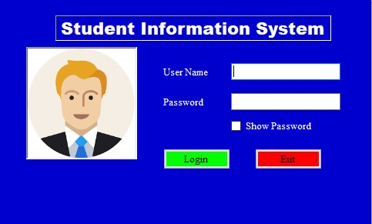

Dashboard Page



Entry Form

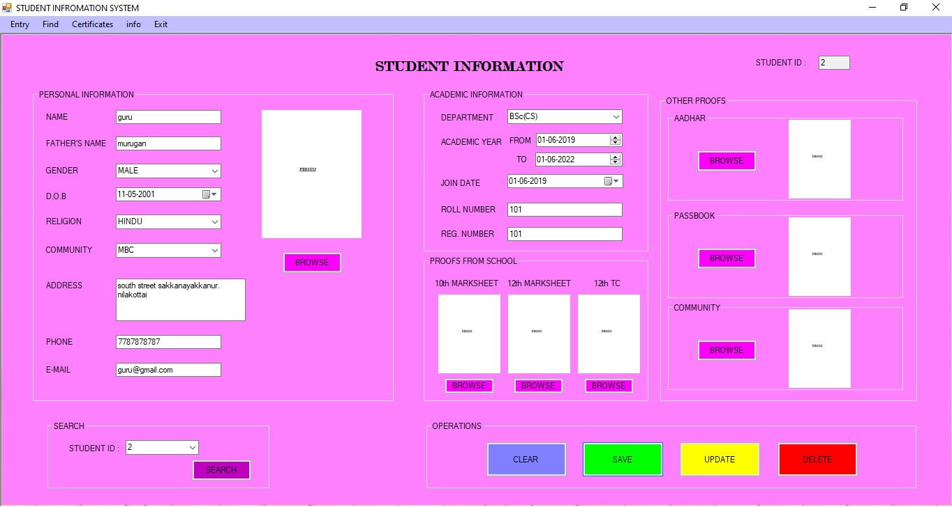

Student Information Viewer

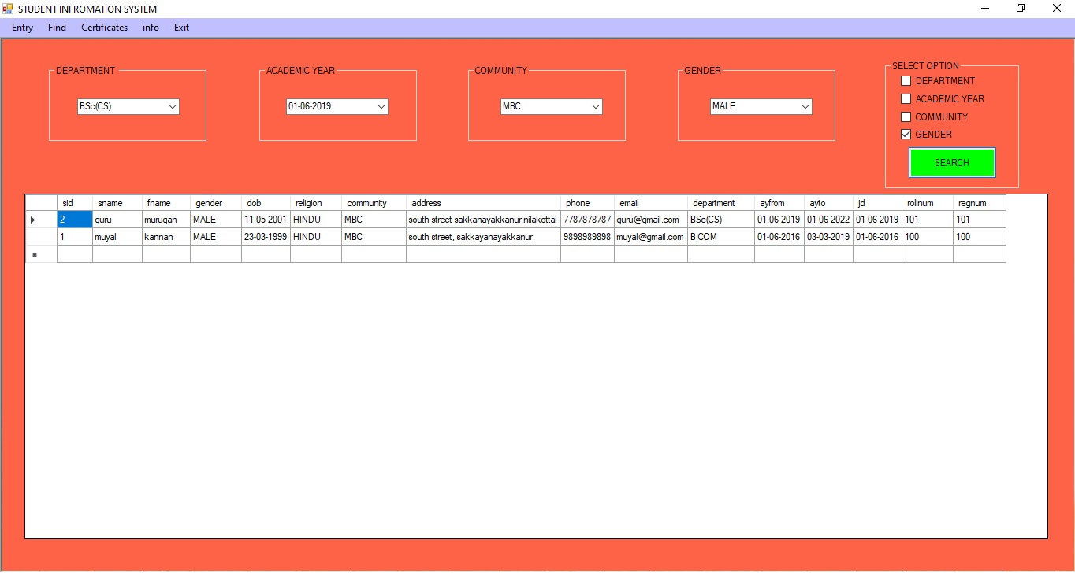

Certificate Viewer

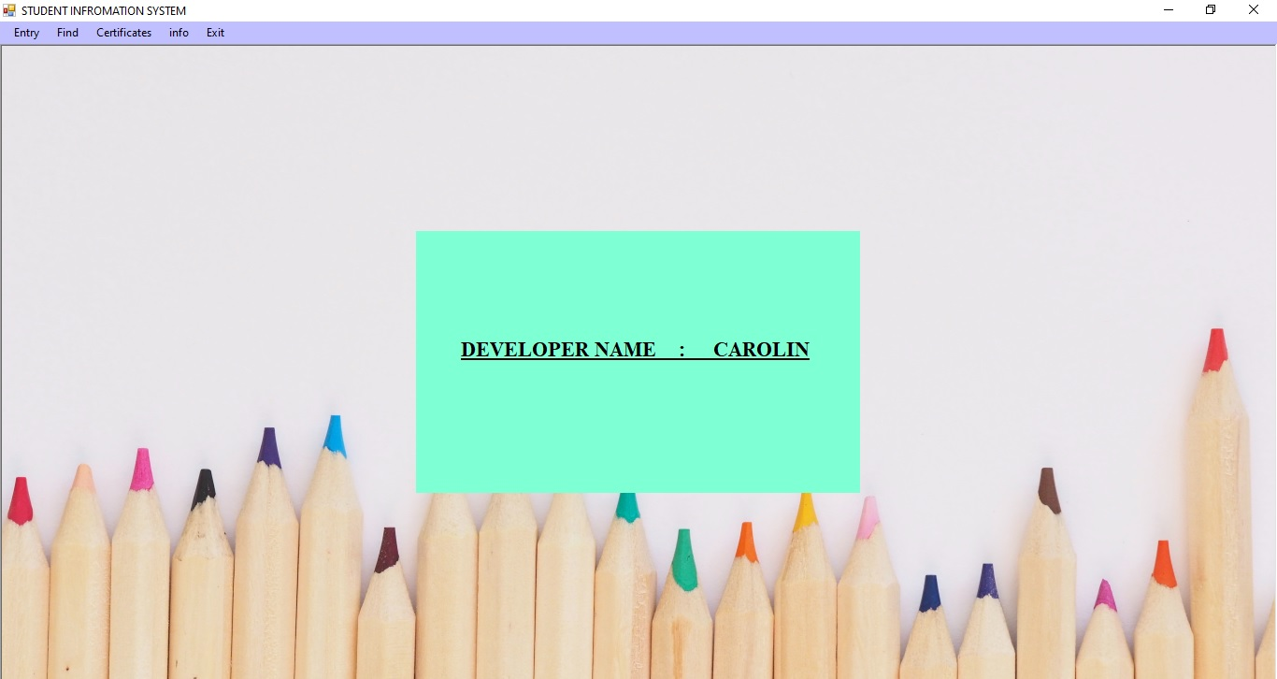

Info Page

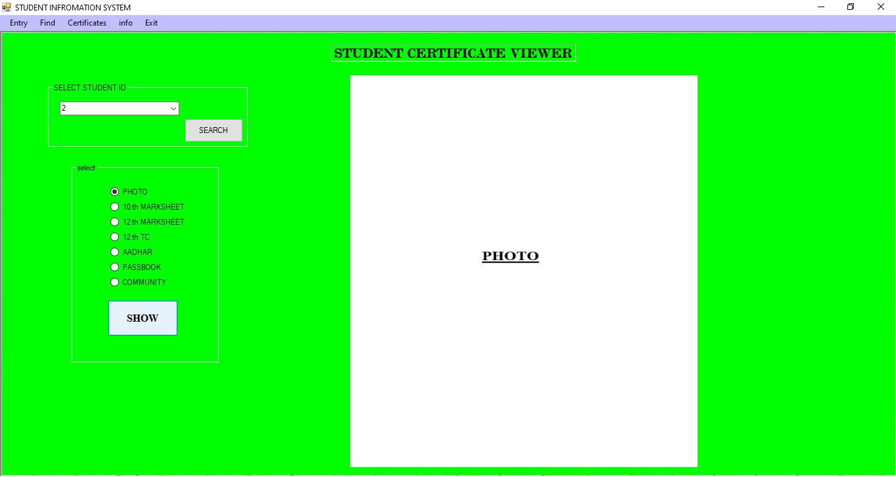

SAMPLE CODING

SAMPLE CODING
Coding for login form
Code for checkbox
Private Sub CheckBox1_CheckedChanged(ByVal sender As System.Object, ByVal e As System.EventArgs) Handles CheckBox1.CheckedChanged
If CheckBox1.Checked = True Then
TextBox2.UseSystemPasswordChar = False
Else
TextBox2.UseSystemPasswordChar = True
End If
End Sub
Code for exit button
Private Sub Button2_Click(ByVal sender As System.Object, ByVal e As System.EventArgs) Handles Button2.Click
Application.Exit()
End Sub
Code for login button
Private Sub Button1_Click(ByVal sender As System.Object, ByVal e As System.EventArgs) Handles Button1.Click
If TextBox1.Text = "admin" And TextBox2.Text = "cath" Then
Form2.Show()
Me.Visible = False
Else
MsgBox("Check the details")
End If

Code for dashboard page
Code for menu tab
Private Sub entrymenu_Click(ByVal sender As System.Object, ByVal e As System.EventArgs) Handles entrymenu.Click
entry.Show()
find.Close()
proofs.Close()
Form3.Close()
End Sub

Code for find tab
Private Sub findmenu_Click(ByVal sender As System.Object, ByVal e As System.EventArgs) Handles findmenu.Click
entry.Close()
find.Show()
proofs.Close()
Form3.Close()
End Sub

Code for certificate tab
Private Sub certificatemenu_Click(ByVal sender As System.Object, ByVal e As System.EventArgs) Handles certificatemenu.Click
entry.Close()
find.Close()
proofs.Show()
Form3.Close()
End Sub

Code for info tab
Private Sub infomenu_Click(ByVal sender As System.Object, ByVal e As System.EventArgs) Handles infomenu.Click
entry.Close()
find.Close()
proofs.Close()
Form3.Show()
End Sub

Code for exit tab
Private Sub exitmenu_Click(ByVal sender As System.Object, ByVal e As System.EventArgs) Handles exitmenu.Click
Application.Exit()
End Sub

Code for entry form

Code for database connection
Dim cn As New OleDbConnection("Provider=Microsoft.ACE.OLEDB.12.0;Data Source=E:\Workshop\VS\SIS\sis.accdb")

Code for formload
Private Sub entry_Load(ByVal sender As System.Object, ByVal e As System.EventArgs) Handles MyBase.Load
Me.MdiParent = Form2
DateTimePicker1.Value = Date.Now.Date
DateTimePicker2.Value = Date.Now.Date
DateTimePicker3.Value = Date.Now.Date
DateTimePicker4.Value = Date.Now.Date

cn.Open()
Dim cmd2 As New OleDbCommand("select * from student", cn)
cmd2.ExecuteNonQuery()
Dim da2 As New OleDbDataAdapter(cmd2)
Dim ds2 As New DataTable
da2.Fill(ds2)
cbsid2.DataSource = ds2
cbsid2.DisplayMember = "sid"
cn.Close()
generateid()

End Sub

Code for picturebox
Private Sub btnphoto_Click(ByVal sender As System.Object, ByVal e As System.EventArgs) Handles btnphoto.Click
Using img1 As OpenFileDialog = New OpenFileDialog

img1.Filter = "choose image(*.jpg;*.png;*.gif)|*.jpg;*.png;*.gif"

If img1.ShowDialog() = DialogResult.OK Then
tbpp.Text = Path.GetFullPath(img1.FileName)

pbphoto.Image = Image.FromFile(img1.FileName)
End If

End Using
End Sub

Code for 10th marksheet browse button
Private Sub btn10m_Click(ByVal sender As System.Object, ByVal e As System.EventArgs) Handles btn10m.Click
Using img1 As OpenFileDialog = New OpenFileDialog

img1.Filter = "choose image(*.jpg;*.png;*.gif)|*.jpg;*.png;*.gif"

If img1.ShowDialog() = DialogResult.OK Then
tb10mp.Text = Path.GetFullPath(img1.FileName)
pb10m.Image = Image.FromFile(img1.FileName)
End If

End Using
End Sub

Code for 12th marksheet browse button
Private Sub btn12m_Click(ByVal sender As System.Object, ByVal e As System.EventArgs) Handles btn12m.Click
Using img1 As OpenFileDialog = New OpenFileDialog

img1.Filter = "choose image(*.jpg;*.png;*.gif)|*.jpg;*.png;*.gif"

If img1.ShowDialog() = DialogResult.OK Then
tb12mp.Text = Path.GetFullPath(img1.FileName)
pb12m.Image = Image.FromFile(img1.FileName)
End If

End Using
End Sub

Code for 12th TC browse button
Private Sub btntc_Click(ByVal sender As System.Object, ByVal e As System.EventArgs) Handles btntc.Click
Using img1 As OpenFileDialog = New OpenFileDialog

img1.Filter = "choose image(*.jpg;*.png;*.gif)|*.jpg;*.png;*.gif"

If img1.ShowDialog() = DialogResult.OK Then
tb12tcp.Text = Path.GetFullPath(img1.FileName)
pbtc.Image = Image.FromFile(img1.FileName)
End If

End Using
End Sub

Code for aadhar browse button
Private Sub btna_Click(ByVal sender As System.Object, ByVal e As System.EventArgs) Handles btna.Click
Using img1 As OpenFileDialog = New OpenFileDialog

img1.Filter = "choose image(*.jpg;*.png;*.gif)|*.jpg;*.png;*.gif"

If img1.ShowDialog() = DialogResult.OK Then
tbap.Text = Path.GetFullPath(img1.FileName)
pba.Image = Image.FromFile(img1.FileName)
End If

End Using
End Sub

Code for passbook browse button
Private Sub btnp_Click(ByVal sender As System.Object, ByVal e As System.EventArgs) Handles btnp.Click
Using img1 As OpenFileDialog = New OpenFileDialog

img1.Filter = "choose image(*.jpg;*.png;*.gif)|*.jpg;*.png;*.gif"

If img1.ShowDialog() = DialogResult.OK Then
tbpbp.Text = Path.GetFullPath(img1.FileName)

pbp.Image = Image.FromFile(img1.FileName)
End If

End Using
End Sub

Code for community certificate browse button
Private Sub btnc_Click(ByVal sender As System.Object, ByVal e As System.EventArgs) Handles btnc.Click
Using img1 As OpenFileDialog = New OpenFileDialog

img1.Filter = "choose image(*.jpg;*.png;*.gif)|*.jpg;*.png;*.gif"

If img1.ShowDialog() = DialogResult.OK Then
tbcomp.Text = Path.GetFullPath(img1.FileName)

pbc.Image = Image.FromFile(img1.FileName)
End If

End Using
End Sub

Code for clear button
Private Sub Button1_Click(ByVal sender As System.Object, ByVal e As System.EventArgs) Handles Button1.Click
tb10mp.Text = ""
tb12mp.Text = ""
tb12tcp.Text = ""
tbadd.Text = ""
tbap.Text = ""
tbcomp.Text = ""
tbfname.Text = ""
tbmail.Text = ""
tbname.Text = ""
tbpbp.Text = ""
tbphone.Text = ""
tbpp.Text = ""
tbreg.Text = ""
tbroll.Text = ""
tbsid1.Text = ""
cbsid2.Text = Nothing
cbcom.Text = Nothing
cbgen.Text = Nothing
cbreligion.Text = Nothing
pb10m.Image = Nothing
pb12m.Image = Nothing
pba.Image = Nothing
pbc.Image = Nothing
pbp.Image = Nothing
pbphoto.Image = Nothing
pbtc.Image = Nothing
generateid()
End Sub

Code for save button
Private Sub Button2_Click(ByVal sender As System.Object, ByVal e As System.EventArgs) Handles Button2.Click
cn.Open()
Dim cmd As New OleDbCommand("insert into student(sid,sname,fname,gender,dob,religion,community,address,phone,email,department,ayfrom,ayto,jd,rollnum,regnum,photop,10mp,12mp,12tcp,aadharp,passbookp,communityp) values ('" & tbsid1.Text & "','" & tbname.Text & "','" & tbfname.Text & "','" & cbgen.Text & "','" & DateTimePicker1.Text & "','" & cbreligion.Text & "','" & cbcom.Text & "','" & tbadd.Text & "','" & tbphone.Text & "','" & tbmail.Text & "','" & cbdept.Text & "','" & DateTimePicker3.Text & "','" & DateTimePicker4.Text & "','" & DateTimePicker2.Text & "','" & tbroll.Text & "','" & tbreg.Text & "','" & tbpp.Text & "','" & tb10mp.Text & "','" & tb12mp.Text & "','" & tb12tcp.Text & "','" & tbap.Text & "','" & tbpbp.Text & "','" & tbcomp.Text & "')", cn)
cmd.ExecuteNonQuery()
MsgBox("Record Added")
cn.Close()
End Sub

Private Sub tbphone_KeyPress(ByVal sender As System.Object, ByVal e As System.Windows.Forms.KeyPressEventArgs) Handles tbphone.KeyPress
Dim ch As Char = e.KeyChar
If Not Char.IsDigit(ch) And Not Char.IsControl(ch) Then
e.Handled = True
End If
End Sub

Private Sub tbname_KeyPress(ByVal sender As System.Object, ByVal e As System.Windows.Forms.KeyPressEventArgs) Handles tbname.KeyPress, tbfname.KeyPress
Dim ch As Char = e.KeyChar
If Char.IsDigit(ch) And Not Char.IsControl(ch) Then
e.Handled = True
End If
End Sub

Code for search button
Private Sub btnss_Click(ByVal sender As System.Object, ByVal e As System.EventArgs) Handles btnss.Click
cn.Open()
Dim cmd1 As New OleDbCommand("select * from student where sid=" & cbsid2.Text & "", cn)
cmd1.ExecuteNonQuery()
Dim dr As OleDbDataReader
dr = cmd1.ExecuteReader
If dr.Read() Then
tbname.Text = dr("sname")
tbsid1.Text = dr("sid")
tbfname.Text = dr("fname")
cbgen.Text = dr("gender")
DateTimePicker1.Text = dr("dob")
cbreligion.Text = dr("religion")
cbcom.Text = dr("community")
tbadd.Text = dr("address")
tbphone.Text = dr("phone")
tbmail.Text = dr("email")
cbdept.Text = dr("department")
DateTimePicker3.Text = dr("ayfrom")
DateTimePicker4.Text = dr("ayto")
DateTimePicker2.Text = dr("jd")
tbroll.Text = dr("rollnum")
tbreg.Text = dr("regnum")
tbpp.Text = dr("photop")
tb10mp.Text = dr("10mp")
tb12mp.Text = dr("12mp")
tb12tcp.Text = dr("12tcp")
tbap.Text = dr("aadharp")
tbpbp.Text = dr("passbookp")
tbcomp.Text = dr("communityp")
pbphoto.Image = Image.FromFile(tbpp.Text)
pb10m.Image = Image.FromFile(tb10mp.Text)
pb12m.Image = Image.FromFile(tb12mp.Text)
pbtc.Image = Image.FromFile(tb12tcp.Text)
pba.Image = Image.FromFile(tbap.Text)
pbp.Image = Image.FromFile(tbpbp.Text)
pbc.Image = Image.FromFile(tbcomp.Text)
Else
MsgBox("enter correct data")
End If
cn.Close()
End Sub

Code for delete button
Private Sub Button4_Click(ByVal sender As System.Object, ByVal e As System.EventArgs) Handles Button4.Click

cn.Open()
Dim cmd3 As New OleDbCommand("delete from student where sid =" & tbsid1.Text & "", cn)
cmd3.ExecuteNonQuery()
MsgBox("Record Deleted")
cn.Close()

End Sub

Code of private function
Private Function generateid() As Double

cn.Open()
Dim cmd6 As New OleDbCommand("select max(sid) from student", cn)
cmd6.ExecuteNonQuery()

Dim dr6 As OleDbDataReader
dr6 = cmd6.ExecuteReader
If dr6.Read Then
If Val(dr6(0)) > 0 Then
Dim b_no As Double
b_no = Val(dr6(0))
tbsid1.Text = (b_no + 1)

ElseIf (Convert.IsDBNull(Val(dr6(0)))) Then
tbsid1.Text = "1"

Else
tbsid1.Text = "1"
End If
End If

cn.Close()
Return (tbsid1.Text)
End Function

Code for update button
Private Sub Button3_Click(ByVal sender As System.Object, ByVal e As System.EventArgs) Handles Button3.Click
cn.Open()
Dim cmd4 As New OleDbCommand("update student set sname='" & tbname.Text & "',fname='" & tbfname.Text & "',gender='" & cbgen.Text & "',dob='" & DateTimePicker1.Text & "',religion='" & cbreligion.Text & "',community='" & cbcom.Text & "',address='" & tbadd.Text & "',phone=" & tbphone.Text & ",email='" & tbmail.Text & "',department='" & cbdept.Text & "',ayfrom='" & DateTimePicker3.Text & "',ayto='" & DateTimePicker4.Text & "',jd='" & DateTimePicker2.Text & "',rollnum='" & tbroll.Text & "',regnum='" & tbreg.Text & "',photop='" & tbpp.Text & "',10mp='" & tb10mp.Text & "',12mp='" & tb12mp.Text & "',12tcp='" & tb12tcp.Text & "',aadharp='" & tbap.Text & "',passbookp='" & tbpbp.Text & "',communityp='" & tbcomp.Text & "' where sid=" & tbsid1.Text & " ", cn)
cmd4.ExecuteNonQuery()
MsgBox("Record Updated")
cn.Close()

End Sub

Code for find form
Code for database connectionn
Dim cn As New OleDbConnection("Provider=Microsoft.ACE.OLEDB.12.0;Data Source=E:\Workshop\VS\SIS\sis.accdb")

Code for fromload
Private Sub find_Load(ByVal sender As System.Object, ByVal e As System.EventArgs) Handles MyBase.Load
Me.MdiParent = Form2

cn.Open()
Dim cmd1 As New OleDbCommand("select distinct department from student", cn)
cmd1.ExecuteNonQuery()
Dim da1 As New OleDbDataAdapter(cmd1)
Dim ds1 As New DataTable
da1.Fill(ds1)
cbdep.DataSource = ds1
cbdep.DisplayMember = "department"
cn.Close()

cn.Open()
Dim cmd2 As New OleDbCommand("select distinct ayfrom from student", cn)
cmd2.ExecuteNonQuery()
Dim da2 As New OleDbDataAdapter(cmd2)
Dim ds2 As New DataTable
da2.Fill(ds2)
cbay.DataSource = ds2
cbay.DisplayMember = "ayfrom"
cn.Close()

cn.Open()
Dim cmd3 As New OleDbCommand("select distinct community from student", cn)
cmd3.ExecuteNonQuery()
Dim da3 As New OleDbDataAdapter(cmd3)
Dim ds3 As New DataTable
da3.Fill(ds3)
cbcom.DataSource = ds3
cbcom.DisplayMember = "community"
cn.Close()

cn.Open()
Dim cmd4 As New OleDbCommand("select distinct gender from student", cn)
cmd4.ExecuteNonQuery()
Dim da4 As New OleDbDataAdapter(cmd4)
Dim ds4 As New DataTable
da4.Fill(ds4)
cbgen.DataSource = ds4
cbgen.DisplayMember = "gender"
cn.Close()
End Sub
Code for search button
Private Sub Button1_Click(ByVal sender As System.Object, ByVal e As System.EventArgs) Handles Button1.Click
If CheckBox1.Checked = True Then
cn.Open()
Dim cmd As New OleDbCommand("select sid,sname,fname,gender,dob,religion,community,address,phone,email,department,ayfrom,ayto,jd,rollnum,regnum from student where department='" & cbdep.Text & "'", cn)
cmd.ExecuteNonQuery()
Dim da As New OleDbDataAdapter(cmd)
Dim dt As New DataTable
da.Fill(dt)
DataGridView1.DataSource = dt
cn.Close()
ElseIf CheckBox2.Checked = True Then
cn.Open()
Dim cmd As New OleDbCommand("select sid,sname,fname,gender,dob,religion,community,address,phone,email,department,ayfrom,ayto,jd,rollnum,regnum from student where ayfrom='" & cbay.Text & "'", cn)
cmd.ExecuteNonQuery()
Dim da As New OleDbDataAdapter(cmd)
Dim dt As New DataTable
da.Fill(dt)
DataGridView1.DataSource = dt
cn.Close()
ElseIf CheckBox3.Checked = True Then
cn.Open()
Dim cmd As New OleDbCommand("select sid,sname,fname,gender,dob,religion,community,address,phone,email,department,ayfrom,ayto,jd,rollnum,regnum from student where community='" & cbcom.Text & "'", cn)
cmd.ExecuteNonQuery()
Dim da As New OleDbDataAdapter(cmd)
Dim dt As New DataTable
da.Fill(dt)
DataGridView1.DataSource = dt
cn.Close()
ElseIf CheckBox4.Checked = True Then
cn.Open()
Dim cmd As New OleDbCommand("select sid,sname,fname,gender,dob,religion,community,address,phone,email,department,ayfrom,ayto,jd,rollnum,regnum from student where gender='" & cbgen.Text & "'", cn)
cmd.ExecuteNonQuery()
Dim da As New OleDbDataAdapter(cmd)
Dim dt As New DataTable
da.Fill(dt)
DataGridView1.DataSource = dt
cn.Close()

ElseIf CheckBox1.Checked = True And CheckBox2.Checked = True Then
cn.Open()
Dim cmd As New OleDbCommand("select sid,sname,fname,gender,dob,religion,community,address,phone,email,department,ayfrom,ayto,jd,rollnum,regnum from student where department='" & cbdep.Text & "' and ayfrom='" & cbay.Text & "' ", cn)
cmd.ExecuteNonQuery()
Dim da As New OleDbDataAdapter(cmd)
Dim dt As New DataTable
da.Fill(dt)
DataGridView1.DataSource = dt
cn.Close()
ElseIf CheckBox1.Checked = True And CheckBox3.Checked = True Then
cn.Open()
Dim cmd As New OleDbCommand("select sid,sname,fname,gender,dob,religion,community,address,phone,email,department,ayfrom,ayto,jd,rollnum,regnum from student where department='" & cbdep.Text & "' and community='" & cbcom.Text & "' ", cn)
cmd.ExecuteNonQuery()
Dim da As New OleDbDataAdapter(cmd)
Dim dt As New DataTable
da.Fill(dt)
DataGridView1.DataSource = dt
cn.Close()
ElseIf CheckBox1.Checked = True And CheckBox4.Checked = True Then
cn.Open()
Dim cmd As New OleDbCommand("select sid,sname,fname,gender,dob,religion,community,address,phone,email,department,ayfrom,ayto,jd,rollnum,regnum from student where department='" & cbdep.Text & "' and gender='" & cbgen.Text & "' ", cn)
cmd.ExecuteNonQuery()
Dim da As New OleDbDataAdapter(cmd)
Dim dt As New DataTable
da.Fill(dt)
DataGridView1.DataSource = dt
cn.Close()
ElseIf CheckBox2.Checked = True And CheckBox3.Checked = True Then
cn.Open()
Dim cmd As New OleDbCommand("select sid,sname,fname,gender,dob,religion,community,address,phone,email,department,ayfrom,ayto,jd,rollnum,regnum from student where ayfrom='" & cbay.Text & "' and community='" & cbcom.Text & "' ", cn)
cmd.ExecuteNonQuery()
Dim da As New OleDbDataAdapter(cmd)
Dim dt As New DataTable
da.Fill(dt)
DataGridView1.DataSource = dt
cn.Close()

ElseIf CheckBox2.Checked = True And CheckBox4.Checked = True Then
cn.Open()
Dim cmd As New OleDbCommand("select sid,sname,fname,gender,dob,religion,community,address,phone,email,department,ayfrom,ayto,jd,rollnum,regnum from student where ayfrom='" & cbay.Text & "' and gender='" & cbgen.Text & "' ", cn)
cmd.ExecuteNonQuery()
Dim da As New OleDbDataAdapter(cmd)
Dim dt As New DataTable
da.Fill(dt)
DataGridView1.DataSource = dt
cn.Close()
ElseIf CheckBox3.Checked = True And CheckBox4.Checked = True Then
cn.Open()
Dim cmd As New OleDbCommand("select sid,sname,fname,gender,dob,religion,community,address,phone,email,department,ayfrom,ayto,jd,rollnum,regnum from student where community='" & cbcom.Text & "' and gender='" & cbgen.Text & "' ", cn)
cmd.ExecuteNonQuery()
Dim da As New OleDbDataAdapter(cmd)
Dim dt As New DataTable
da.Fill(dt)
DataGridView1.DataSource = dt
cn.Close()
ElseIf CheckBox1.Checked = True And CheckBox2.Checked = True And CheckBox3.Checked = True Then
cn.Open()
Dim cmd As New OleDbCommand("select sid,sname,fname,gender,dob,religion,community,address,phone,email,department,ayfrom,ayto,jd,rollnum,regnum from student where department='" & cbdep.Text & "'and ayfrom='" & cbay.Text & "' and community='" & cbcom.Text & "' ", cn)
cmd.ExecuteNonQuery()
Dim da As New OleDbDataAdapter(cmd)
Dim dt As New DataTable
da.Fill(dt)
DataGridView1.DataSource = dt
cn.Close()
ElseIf CheckBox1.Checked = True And CheckBox2.Checked = True And CheckBox4.Checked = True Then
cn.Open()
Dim cmd As New OleDbCommand("select sid,sname,fname,gender,dob,religion,community,address,phone,email,department,ayfrom,ayto,jd,rollnum,regnum from student where department='" & cbdep.Text & "'and ayfrom='" & cbay.Text & "' and gender='" & cbgen.Text & "' ", cn)
cmd.ExecuteNonQuery()
Dim da As New OleDbDataAdapter(cmd)
Dim dt As New DataTable
da.Fill(dt)
DataGridView1.DataSource = dt
cn.Close()
ElseIf CheckBox1.Checked = True And CheckBox4.Checked = True And CheckBox3.Checked = True Then
cn.Open()
Dim cmd As New OleDbCommand("select sid,sname,fname,gender,dob,religion,community,address,phone,email,department,ayfrom,ayto,jd,rollnum,regnum from student where department='" & cbdep.Text & "'and gender='" & cbgen.Text & "' and community='" & cbcom.Text & "' ", cn)
cmd.ExecuteNonQuery()
Dim da As New OleDbDataAdapter(cmd)
Dim dt As New DataTable
da.Fill(dt)
DataGridView1.DataSource = dt
cn.Close()
ElseIf CheckBox4.Checked = True And CheckBox2.Checked = True And CheckBox3.Checked = True Then
cn.Open()
Dim cmd As New OleDbCommand("select sid,sname,fname,gender,dob,religion,community,address,phone,email,department,ayfrom,ayto,jd,rollnum,regnum from student where gender='" & cbgen.Text & "'and ayfrom='" & cbay.Text & "' and community='" & cbcom.Text & "' ", cn)
cmd.ExecuteNonQuery()
Dim da As New OleDbDataAdapter(cmd)
Dim dt As New DataTable
da.Fill(dt)
DataGridView1.DataSource = dt
cn.Close()
ElseIf CheckBox1.Checked = True And CheckBox2.Checked = True And CheckBox3.Checked = True And CheckBox4.Checked = True Then
cn.Open()
Dim cmd As New OleDbCommand("select sid,sname,fname,gender,dob,religion,community,address,phone,email,department,ayfrom,ayto,jd,rollnum,regnum from student where department='" & cbdep.Text & "'and ayfrom='" & cbay.Text & "' and community='" & cbcom.Text & "' and gender='" & cbgen.Text & "' ", cn)
cmd.ExecuteNonQuery()
Dim da As New OleDbDataAdapter(cmd)
Dim dt As New DataTable
da.Fill(dt)
DataGridView1.DataSource = dt
cn.Close()
Else
cn.Open()
Dim cmd As New OleDbCommand("select sid,sname,fname,gender,dob,religion,community,address,phone,email,department,ayfrom,ayto,jd,rollnum,regnum from student ", cn)
cmd.ExecuteNonQuery()
Dim da As New OleDbDataAdapter(cmd)
Dim dt As New DataTable
da.Fill(dt)
DataGridView1.DataSource = dt
cn.Close()
Code for certificate form

Code for database connection
Dim cn As New OleDbConnection("Provider=Microsoft.ACE.OLEDB.12.0;Data Source=E:\Workshop\VS\SIS\sis.accdb")

Code for print button
Private Sub btnprint_Click(ByVal sender As System.Object, ByVal e As System.EventArgs) Handles btnprint.Click
If RadioButton7.Checked = True Then
PictureBox1.Image = Image.FromFile(tbphoto.Text)
ElseIf RadioButton1.Checked = True Then
PictureBox1.Image = Image.FromFile(tb10m.Text)
ElseIf RadioButton2.Checked = True Then
PictureBox1.Image = Image.FromFile(tb12m.Text)
ElseIf RadioButton3.Checked = True Then
PictureBox1.Image = Image.FromFile(tbtc.Text)
ElseIf RadioButton4.Checked = True Then
PictureBox1.Image = Image.FromFile(tbaadhar.Text)
ElseIf RadioButton5.Checked = True Then
PictureBox1.Image = Image.FromFile(tbpb.Text)
ElseIf RadioButton6.Checked = True Then
PictureBox1.Image = Image.FromFile(tbcom.Text)
End If

End Sub

Code for formload
Private Sub proofs_Load_1(ByVal sender As System.Object, ByVal e As System.EventArgs) Handles MyBase.Load
Me.MdiParent = Form2
cn.Open()
Dim cmd As New OleDbCommand("select * from student", cn)
cmd.ExecuteNonQuery()
Dim da As New OleDbDataAdapter(cmd)
Dim ds As New DataTable
da.Fill(ds)
ComboBox1.DataSource = ds
ComboBox1.DisplayMember = "sid"
cn.Close()
End Sub

Code for search button
Private Sub Button1_Click_1(ByVal sender As System.Object, ByVal e As System.EventArgs) Handles Button1.Click
cn.Open()
Dim cmd1 As New OleDbCommand("select * from student where sid=" & ComboBox1.Text & "", cn)
cmd1.ExecuteNonQuery()
Dim dr As OleDbDataReader
dr = cmd1.ExecuteReader
If dr.Read() Then
tbphoto.Text = dr("photop")
tb10m.Text = dr("10mp")
tb12m.Text = dr("12mp")
tbtc.Text = dr("12tcp")
tbaadhar.Text = dr("aadharp")
tbpb.Text = dr("passbookp")
tbcom.Text = dr("communityp")
Else
MsgBox("enter correct data")
End If
cn.Close()
End Sub

ABOUT THE SOFTWARE

ABOUT THE SOFTWARE
VB.NET
VB.Net has revolutionized windows programming windows programming and with an object based, event driven approach to software designs. Visual basic.Net applications act as a front end to the database. Visual basic.Net application provides the interface between the user and the database. Sophisticated features that make the language truly object oriented and interfaces it with the latest in the database technology.
.NET provides a new, object-oriented API as a set of classes that will be accessible from any programming language. This book describes this framework of classes and provides a reference to what is available and how you can use this framework to write Windows applications in the brave new world of .NET.
Microsoft .NET Framework is a computing platform for developing distributed applications for the Internet. Following are the design goals of Microsoft .NET Framework:
- To provide a very high degree of language interoperability
- To provide a runtime environment that completely manages code execution
- To provide a very simple software deployment and versioning model
- To provide high-level code security through code access security and strong type checking
- To provide a consistent object-oriented programming model
- To facilitate application communication by using industry standards such as SOAP and XML.
- To simplify Web application development
Visual basic.net lets the user to add menus, text boxes, command buttons, option buttons, check boxes, list boxes, scroll bars, and file directory boxes to blank windows. Visual basic.net has many different tools.

The Common Language Runtime
The CLR is the mechanism through which .NET code is executed. It is built upon a single, common language—IL—into which source languages are compiled and includes mechanisms for executing the compiled code. This includes code verification and just-in-time (JIT) compilation, garbage collection and enforcement of security policies, and the provision of profiling and debugging services.
The CLR provides a lot of added value to the programs it supports. Because it controls how a .NET program executes and sits between the program and the operating system, it can implement security, versioning support, automatic memory management through garbage collection, and provide transparent access to system services.
The user interface is the part of the program that responds to the key press and mouse clicks. The action is referred to as events of the form and controls in the form. The form is a visual object where a set of object controls is placed to communicate with backend databases and validation checks. VB.NET provides a vast properties and methods for each control, which helps to utilize all those, functions for record manipulations.
IMPORTANT FEATURES
- The application is a graphical user interface.
- Client-Server architecture benefits picture and image box can be easily handled using bit mapped files and icons.
- Bit mapped files and icons are used as simple debugging tools.
- With the advent of .NET, Microsoft has introduced many new technologies that make writing component-based distributed systems easier, more flexible, and more powerful than ever before.
- It is now easier than it has ever been to write components in any programming language that can interoperate with components on other machines, which may not be Windows-based at all.

MS ACCESS
The purpose of this document is to help you migrate your applications when you are migrating the underlying database from Microsoft Access to Some other Database. Most of the issues encountered when migrating applications to use an MS Access Database are related to database incompatibility. This paper presents these incompatibilities and provides solutions for many issues. It familiarizes yourself with this document prior to migrating your databases. The choices made about how to migrate your application affect how you migrate the underlying database from Microsoft Access to some other Database.
If the application uses the Microsoft OLE DB Provider for MS Access or a third-party OLE DB Provider to connect the Microsoft Access database, use the Microsoft.ACE.OLEDB.12.0 Provider for OLE DB (Microsoft.ACE.OLEDB.12.0) to connect to the migrated Database.
There are quite a few reasons, the first being that MS Access is a feature rich program that can handle any database related task you have. You can create places to store your data build tools that make it easy to read and modify your database contents, and ask questions of your data. MS Access is a relational database, a database that stores information about related objects. In MS Access that database means a collection of tables that hold data. It collectively stores all the other related objects such as queries, forms and reports that are used to implement function effectively.

